# UAT Testing

Launch IT Incident Logger on Desktop

Select General Service Request

Complete Request as per below, but with correct version number:

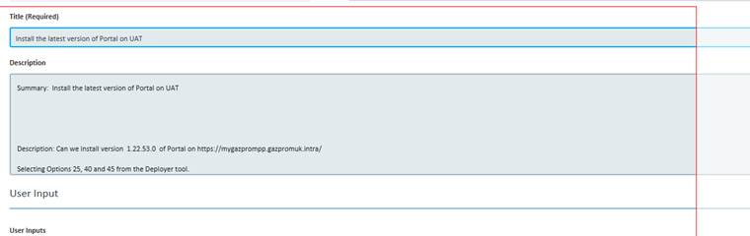

Once email is received from IT Service Desk to say that this is done, run manual smoke tests on UAT environment (**UAT Link**

<https://mygazprompp.gazpromuk.intra/Account/Login?ReturnUrl=%2F>

).

NOTE: If it takes more than a day to come back, give Phil (beside John) a nudge.

If UAT smoke tests pass, then email Tiziana Masssa & Sales –Ian Kendrick (cc) to ask them to sign off on UAT (send them the UAT link)

Once UAT sign off received, update latest Release notes Known Bugs and Test Results (Acceptance Tests ) sections.

(Toli will have created it, you just update it)